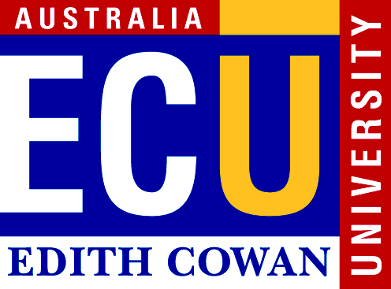
ANIMAL ethics committee
For all queries, please contact:
Research Ethics Office
Edith Cowan University
270 Joondalup Drive
JOONDALUP WA 6027
Phone: 6304 2170
Fax: 6304 2661
Email: research.ethics@ecu.edu.au

accidental bycatch

All applicants undertaking projects involving the use of animals for scientific purposes, including teaching, are required to comply with the Australian code for the care and use of animals for scientific purposes (2013) (the Code) and the Animal Welfare Act (2002).

The Code defines an animal as:
any live non-human vertebrate; that is, fish, amphibians, reptiles, birds and mammals, encompassing domestic animals, purpose-bred animals, livestock and wildlife, and also cephalopods such as octopus and squid

Projects involving invertebrate species
An application for ethics approval to the Animal Ethics Committee (AEC) is not required for projects that involve invertebrate species. However, an Ethics Declaration should be completed for research projects.

The Ethics Declaration can be completed using STREAM: https://stream.ecu.edu.au/

Accidental Bycatch

This situation is managed using a two stage process:
- Notification Form
If there is a possibility that accidental bycatch of animals (as defined in the Code) may occur, investigators or teachers should complete the Accidental Bycatch Notification Form. This will enable the AEC to establish that the impact of the project on animals has been considered and that appropriate strategies are in place to ensure that the care and welfare of animals has been taken into account.

- Report Form
If accidental bycatch of animals does occur, researchers must inform the AEC and complete an Accidental Bycatch Report Form. If management of accidental bycatch differs from the methods outlined in the Notification Form, this should be explained and justified on the form.

PROCEDURES FOR COMPLETION OF accidental bycatch FORMs

- Forms should be completed using typewriting or word processing.
- The completed forms should be submitted via email for processing to the Research Ethics Office.
- The Accidental Bycatch Notification Form should be completed and sent to the Research Ethics Office for noting by the AEC prior to the project commencing.
- If accidental bycatch of animals occurs, the Research Ethics Office should be notified and the Accidental Bycatch Report Form should be completed.
- Accidental Bycatch Report Forms are reviewed by the AEC and researchers or teachers may be contacted if the AEC has any queries.

Accidental Bycatch Forms (Notification and Report) are available from the Ethics website
https://intranet.ecu.edu.au/research/research-ethics/animal-ethics-applications/resources

ANIMAL ethics committee
For all queries, please contact:
Research Ethics Officer
Edith Cowan University
270 Joondalup Drive
JOONDALUP WA 6027
Phone: 6304 2170
Fax: 6304 2661
Email: research.ethics@ecu.edu.au

ACCIDENTAL BYCATCH
REPORT FORM

PROJECT DETAILS
Project code
Project title
Chief Investigator
Date of report

Type of Project
Staff Research |  | Masters (Coursework) |  | Doctorate/PhD
Honours |  | Masters (Research) |  | Other:

DESCRIPTION OF PROJECT
Please provide a brief description of the project.
Has an accidental bycatch notification form been submitted for this project? YES ◻ NO ◻

BYCATCH OF ANIMALS
Provide details of the species and number of animals that were accidentally caught.
Indicate how accidental bycatch of animals occurred.

MANAGEMENT OF ACCIDENTAL BYCATCH
Indicate how the accidental bycatch of animals was managed.
Provide details of the methods that were used to minimise pain and distress, and details of euthanasia procedures performed (if this was necessary).
Indicate who was responsible for managing bycatch and conducting the euthanasia procedures.
If the management of accidental bycatch differed from the method outlined in the Notification Form, provide an explanation and justification.

