**Business Case**

|  |  |  |
| --- | --- | --- |
| Title |  | |
| Initiated By |  | Date: |
| Project Executive |  | Project Owner: |
| School / SC |  | |
| Project Type | Compliance, Replacement Project, New Initiative (refer Glossary) | |
| Developed By | *(Author of this Business Case)* | |
| In consultation with |  | |

**Version Control**

|  |  |  |
| --- | --- | --- |
| Date | Author | Notes |
|  |  |  |
|  |  |  |
|  |  |  |
|  |  |  |

**Consultation**

|  |  |  |
| --- | --- | --- |
| Name | Title | School / Service Centre |
|  |  |  |
|  |  |  |
|  |  |  |
|  |  |  |
|  |  |  |
|  |  |  |
|  |  |  |

**Approval**

|  |  |  |
| --- | --- | --- |
| Name |  | Date |
|  |  |  |
|  |  |  |

*Note: Italics throughout this document are for explanatory purposes and can be deleted.*

Contents

1. Executive Summary 3

2. Project Overview 4

3. Options Summary 7

4. Approach 8

5. Financial Summary 9

6. Recommendation 9

7. Approved by 9

8. Appendix A – Technology 11

9. Appendix B - Options Assessment 12

10. Appendix C – Financial Model 15

11. Supporting Information 16

# Executive Summary

## Overview

*Include an Executive level overview of the business case outlining the anticipated outcome, any key considerations and the cost of the recommended solution. This page should adequately summarise key elements of the business case for decision making and should identify where this project is part of a larger program of work and whether it is critical for the success of that program.*

TEXT

## Benefits

*Include a summary of the anticipated benefits relating back to the University Strategic Plan. More detailed benefits information will be provided later in the document.*

* TEXT
* TEXT
* TEXT

## Cost

*Provide a summary of the cost (implementation and ongoing), including the cost of potential options and the recommended approach (including phases if applicable).*

*Costs need to be reviewed by a Finance Business Partner.*

|  |  |  |  |  |  |  |
| --- | --- | --- | --- | --- | --- | --- |
| *Option* | *Implementation Cost* | *Annual Ongoing Cost* | Total Cost Over 5 Years | Annual Savings / Incremental Revenue | NPV over 5 Years @ 7% | Payback Period |
|  |  |  |  |  |  |  |
|  |  |  |  |  |  |  |
|  |  |  |  |  |  |  |
|  |  |  |  |  |  |  |

Cost certainty factor: *(+/- XX e.g. +/- 20%)*

Note:

* + - Project financials should be over the one useful lifecycle of the investment.
    - Columns for annual savings/incremental revenue - only required for projects that are expected to generate savings or increase revenue.
    - Column for Payback Period - only required for projects that are expected to generate savings or increase revenue.
    - Consult with your Finance Business partner for advice and feedback.

# Project Overview

## Business Justification (Why)

What is the business driver for this project? What is the current state? What are the challenges and opportunities? How is this project critical for achievement of a larger program of work (if applicable)? TEXT

## Compliance Projects (delete if not applicable)

*If this project is considered mandatory for compliance reasons, provide information on the legislative or regulatory body requirements driving the need for the project; the timing of the compliance requirement and the consequences of non-compliance. Please refer to the glossary for a definition of a compliance project.*

|  |  |  |
| --- | --- | --- |
| Compliance Information | | |
| Compliance Justification |  | |
| Regulatory Body |  | |
| Audit Findings |  | |
| Business Continuity Impact |  | |
| Min Compliance Required |  | Date Required: |
| Max Compliance Required |  | Date Required: |
| Penalty for non-compliance |  | |

## Strategic Value

Provide information on how this project supports the University’s [strategic goals and objectives](https://strategicplan.ecu.edu.au/) and the specific area’s operational plan.

TEXT

|  |  |  |  |  |
| --- | --- | --- | --- | --- |
|  | Strategic Alignment – Goals & Objectives (tick as appropriate) | | | |
| **Student Experience** | **Research** | I**nternationalisation** | **Empowering our staff** | **Securing our future** |
| Objective 1  Objective 2  Objective 3  Objective 4  Objective 5 | Objective 6  Objective 7  Objective 8  Objective 9 | Objective 10  Objective 11  Objective 12  Objective 13  Objective 14 | Objective 15  Objective 16  Objective 17  Objective 18 | Objective 19  Objective 20  Objective 21  Objective 22  Objective 23 |
|  | Value / Complexity - Rank the following using the criteria in Appendix B (n/a for compliance initiatives) | | | |
| Strategic Alignment & Reputation | Benefits realisation | Technical & Delivery Complexity | Change Impact | Cost & Time |
|  |  |  |  |  |

## Outcomes

The project will deliver the following outcomes to achieve the benefits outlined.

|  |  |  |
| --- | --- | --- |
| # | Outcomes | Outcome Description |
| O1 |  |  |
| O2 |  |  |
| 03 |  |  |
| 04 |  |  |
| 05 |  |  |

## Detailed Benefits

*Include detailed benefits with SMART (refer glossary) measures and a proposed Benefit Owner (refer Glossary). Consider ECU strategic goals and targets when developing these benefits.*

|  |  |  |  |
| --- | --- | --- | --- |
| 4.3 Benefits (be specific and include realistic, measurable, timely targets) | | | |
| Benefit Category | Benefit Description | Timing | Owner |
| 1: Generates Revenue |  |  |  |
| 2: Cost reduction |  |  |  |
| 3. Efficiency |  |  |  |
| 4: Reputation |  |  |  |
| 5: Maintains revenue |  |  |  |
| 6: Risk reduction |  |  |  |
| 7. Student outcomes / experience |  |  |  |
| 8. Staff & Culture |  |  |  |

## Disbenefits

*Identify any disadvantages or negative outcomes which are very likely or are certain consequences of this project.*

TEXT

## Scope

At a very high level what will and will not be included?

TEXT

## Impact

*Which groups of stakeholders might be interested in or impacted by this change?*

TEXT

What type of impact will there be?

|  |  |
| --- | --- |
| Impact Type | Description and degree of impact (High, Medium, Low) |
| People | Describe the impact on culture and degree of change to staff, students or other stakeholders.  TEXT |
| Process | Describe the type of process change and the degree of change across ECU.  TEXT |
| Technology | Describe the type of technology change, the impacted systems, the dependencies and the degree of change for users.  TEXT |
| Policy | Describe the type of policy change and the degree of change across ECU.  TEXT |
| Role | Describe any changes to specific roles, performance management, recognition and reward and who these changes will apply to.  TEXT |
| Org Structure | Describe any changes to the organisational structure.  TEXT |

## Technology Summary

Technology impact, dependencies, interfaces and assessments to be included here or as an Appendix.

TEXT

## Assumptions

List any assumptions made which have influenced the information in this Business Case.

* TEXT
* TEXT

## Dependencies and Constraints

List any key dependencies or constraints which will impact the University’s ability to proceed with this project, including critical elements of this project which contribute to a larger program of work.

* TEXT
* TEXT

## Key Risks

Risk management planning will be undertaken during project planning. List any key risks below:

### Risks associated with proceeding

* TEXT
* TEXT

### Risks of not proceeding

* TEXT
* TEXT

# Options Summary

*The detailed options assessment should be included as an Appendix (refer to Appendix for guidelines) with a summary provided below.*

## Identified Options

### Option 1 – Do Nothing

*Provide a brief overview of this option.*

### Option 2 – NAME

*Provide a brief overview of this option.*

## Summary of Options

*Complete the Options Assessment in the Appendix first, to determine the percentage alignment with each of the criteria. Include this summary in the table below.*

Each of the options has been assessed against specific criteria as outlined below and given a score of 3 (meets criteria), 2 (partially meets) or 1 (does not meet), to determine the % alignment.   
Detailed ratings can be found in the Appendix.

|  |  |  |
| --- | --- | --- |
| Criteria Assessed | Option 1 – TEXT | Option 2- TEXT |
| Strategic Alignment |  |  |
| Outcome Alignment |  |  |
| Benefits Alignment |  |  |
| Risk Profile |  |  |
| Project Implementation Cost |  |  |
| Disbenefit implications (H, M, L) |  |  |

## Recommended Option

Based on the assessment of strategic alignment, outcomes, benefits and risks, the recommended option is:

TEXT

# Approach

## Implementation Approach

*Note any phases, the overall implementation approach, the preferred timeline and where this fits within any identified broader program of work. The approach and timeline should reflect the options presented.*

TEXT

## Project Structure

*Include recommended Project Executive, Project Owner, Lead Delivery Team and Key Business Areas. If this project is part of a program of work, the structure should be consistent with and interact with any existing program governance structures in place.*

## Resource Needs

Estimate the resource needs based on your current understanding.

* Which team will be required?
* What skills will be required?
* How much time will be required from each resource over what timeframe?

|  |  |  |  |
| --- | --- | --- | --- |
| Team | Skills Required | Months Required | Days per Week |
| *Eg.IT* | Salesforce architecture skills | Jan – Jun | 2 |
|  |  |  |  |
|  |  |  |  |
|  |  |  |  |
|  |  |  |  |
|  |  |  |  |

# Financial Summary

## Project Cost

|  |  |  |  |  |
| --- | --- | --- | --- | --- |
| Description | Option 1 1Year 1 | Option 1 Year 2 | Option 2 1Year 1 | Option 2 Year 2 |
| IT Delivery Costs |  |  |  |  |
| Marketing |  |  |  |  |
| Training and Support |  |  |  |  |
| Additional Resources (attach details in Appendix) |  |  |  |  |
| Other Operational (eg. Site visits, contingency) |  |  |  |  |
| Total |  |  |  |  |
| Contingency |  |  |  |  |
| Total including Contingency |  |  |  |  |

## Financial Model

Financial modelling to be reviewed by a Finance Business Partner / provided by FSBC and attached as an Appendix.

## Costing by Phase

* + - * XX
      * XX

# Recommendation

It is recommended that approval is provided to proceed with:

TEXT

# Approved by

|  |  |  |
| --- | --- | --- |
|  |  | |
| Approval of: | e.g. Option X, procurement activity etc. | |
| Project Executive: | *Name / Title* | *Date:* |
| Financial Review | *Name / Title* | *Date:* |
| Business Area Manager / Director: | *Name / Title* | *Date:* |
| Business / System Owner: | *Name / Title* | *Date:* |

# Appendix A – Technology

# Appendix B - Options Assessment

Two options have been identified for assessment.

1. TEXT
2. TEXT

Each of these options has been assessed against criteria associated with ECU strategic objectives; the outcomes and benefits outlined in this document; risk; and cost.

## Identified Options

### Option 1 – Do Nothing

TEXT

### Option 1 - TEXT

TEXT

## Summary of Options

Each of the options was assessed against the criteria in the table below and given a score of 3 (meets criteria), 2 (partially meets) or 1 (does not meet), to determine the % alignment. The percentage by which each option addressed the criteria is shown below.

|  |  |  |
| --- | --- | --- |
| Criteria Assessed (summary from sections below) | Option 1 - *TEXT* | Option 2 - *TEXT* |
| Strategic Alignment |  |  |
| Outcome Alignment |  |  |
| Benefits Alignment |  |  |
| Risk Profile |  |  |
| Project Implementation Cost |  |  |
| Disbenefit implications (H,M,L) |  |  |

## Strategic Alignment

Score of 3 (meets criteria), 2 (partially meets) or 1 (does not meet)

|  |  |  |
| --- | --- | --- |
| Strategic Objectives - | Option 1 | Option 2 |
| Delivering an exceptional student experience for success in work and life |  |  |
| Objective 1 - Personalised learning and study support |  |  |
| Objective 2 - Quality and consistency across all modes and locations of study |  |  |
| Objective 3 - Graduates empowered to succeed |  |  |
| Objective 4 - Promoting equity, diversity and excellence |  |  |
| Objective 5 - Success for Aboriginal and Torres Strait Islander students |  |  |
| Undertaking impactful world-class research |  |  |
| Objective 6 - Focused, world-class research |  |  |
| Objective 7 - A strong research culture |  |  |
| Objective 8 - Highly valued higher degree by research graduates |  |  |
| Objective 9 - Partnerships for research |  |  |
| Leading the sector in internationalisation |  |  |
| Objective 10 - International recovery and growth |  |  |
| Objective 11 - Global relationships |  |  |
| Objective 12 - Strengthening offshore delivery |  |  |
| Objective 13 - International partnerships for research students |  |  |
| Objective 14 - An internationalised student experience |  |  |
| Empowering the talent and potential of our staff |  |  |
| Objective 15 - A workforce ready for the future |  |  |
| Objective 16 - Establish a contemporary approach to academic careers |  |  |
| Objective 17 - A workforce that reflects our communities |  |  |
| Objective 18 - Transformation, resilience and excellence |  |  |
| Securing our future |  |  |
| Objective 19 - Towards the University of the Future |  |  |
| Objective 20 - Course renewal and rationalisation |  |  |
| Objective 21 - Strong regional communities |  |  |
| Objective 22 - Social change imperatives |  |  |
| Objective 23 - Financial sustainability |  |  |

## Outcome Alignment

Score of 3 (meets criteria), 2 (partially meets) or 1 (does not meet)

|  |  |  |  |  |
| --- | --- | --- | --- | --- |
| # | Category | Outcome | Option 1 | Option 2 |
| O1 |  |  |  |  |
| O2 |  |  |  |  |
| O3 |  |  |  |  |
| O4 |  |  |  |  |
| O5 |  |  |  |  |

## Benefits Alignment

Score of 3 (meets criteria), 2 (partially meets) or 1 (does not meet)

|  |  |  |  |
| --- | --- | --- | --- |
| # | Benefit Description | Option 1 | Option 2 |
| O1 |  |  |  |
| O2 |  |  |  |
| O3 |  |  |  |
| O4 |  |  |  |
| O5 |  |  |  |

## Key Risks by Option

|  |
| --- |
| Option 1 – TEXT |
|  |
|  |

|  |
| --- |
| Option 2 – TEXT |
|  |
|  |

## Recommended Option

Based on the assessment of strategic alignment, outcomes, benefits and risks, the recommended option is:

TEXT

# Appendix C – Financial Model

# Supporting Information

## Value Complexity Scoring



## Glossary

|  |  |
| --- | --- |
| Assumption | Assumptions are factors that, for planning purposes, are considered to be true, real, or certain without proof or demonstrations (PMBOK® Guide 5th Edition). . |
| Benefits Owner | Successful delivery of benefits relies on a partnership between the project team and the impacted business areas. The Benefits Owner will represent the business area(s) impacted and will be responsible for delivering the benefits post implementation. The Benefits Owner is a key stakeholder who will be involved in the development, implementation and management of benefits throughout the project. |
| Business System Owner | Business Owner as identified in the IT Technical Services Register. Responsible for decision making and changes related to a particular system and the business continuity planning for that system. |
| Compliance Project | A project initiated which is required to address requirements imposed by law, a regulatory body or government agency. |
| Constraint | A limitation or restriction which is certain and will affect the project. |
| Disbenefit | Most commonly defined as a disadvantage or drawback. In the context of projects, a disbenefit is any perceived or expected negative outcome or consequence as a result of the project e.g. loss of greenery and natural environment due to a new building. |
| Lead Delivery Team | The Lead Delivery Team, as identified in a Business Improvement Project, is a team nominated to manage and deliver a project, according to the planning, design and delivery phases within existing methodologies. |
| New Initiative | A project initiated to introduce new capabilities to the University. |
| Program | [1] A group of related projects managed in a coordinated way to obtain benefits and control not available from managing them individually.. |
| Program Executive | The Program Executive is responsible for ensuring the ongoing viability of the program and provides high level direction and strategic context.  The Program Executive holds the budget and is the final escalation point and decision-maker. |
| Program Manager | The Program Manager is responsible for developing the Program Definition Plan and supporting plans (including benefits management, stakeholder engagement, program risk management). They monitor and manage program delivery including budget, risks, issues and dependencies, manage coordination and support across the projects to ensure alignment and management of dependencies and impacts and report on program performance to the Program Executive and the Steering Committee. |
| Program Steering Committee (or Program Board) | Program Steering Committee (or Program Board) oversees program activities to ensure delivery of agreed outcomes and benefits within agreed boundaries, approves the Business Case and key program documents and makes timely decisions, supports delivery according to the Program Definition Plan. They also resolve strategic and directional issues between projects, ensure appropriate program governance and due diligence and define acceptable risk thresholds and monitors key risks. |
| Project Board | The Project Board is a decision-making committee, led and chaired by the Project Executive. The Project Board is responsible for the oversight of the project to ensure it delivers in accordance with approved baselines and enables the achievement of benefits. This includes management of business issues associated with the project which is essential to ensuring the delivery of the project outputs and the attainment of project outcomes. The Project Board approves key project deliverables, resolves escalated risks and ensures compliance with ECU governance frameworks. |
| Project Executive | An Executive Manager who is responsible for ensuring the ongoing viability of the project and provision of high-level direction and strategic context. The Project Executive oversees development of the Business Case, authorises expenditure, sets tolerances, and is the final escalation point and decision-maker. |
| Project Manager | A Project Manager is assigned to a project and is responsible for planning, management, reporting and day-to-day delivery, ensuring the project continues to focus on delivery of project outcomes within the approved scope, time, quality and cost parameters. This includes detailed project planning; co-ordination across streams; reporting; and management of risks, actions, issues, dependencies, schedule, resources, change management, project communication and budget. |
| Project Owner | A Manager responsible for transitioning the benefits of the project into operations once the project is complete. The Project Owner will provide ongoing decision making and guidance to the project team, interpret the needs of the Project Executive and work closely with team to ensure the project delivers the intended business benefits. |
| Project Working Group | The Project Working Group reports to the Project Board and includes subject matter experts, to ensure the various requirements, impacts and dependencies across multiple stakeholder groups are considered and managed. The Project Working Group is comprised of stream leads who will be responsible for leading specific project streams. |
| Replacement Project | A project initiated by the University to replace existing systems, processes or policies. |
| Senior Supplier | For technology projects, where relevant, a Senior Supplier is appointed to the Project Board responsible for ensuring quality products are supplied to specification on time. They will provide skills, knowledge and help to identify and resolve any issues impacting delivery. |
| Senior User | For technology projects, a Senior User is appointed to the Project Board responsible for validating the end product(s) meet the requirements as perceived and agreed by the University. They will provide a single interface to the ‘end users’ for functionality and are responsible for verifying the solution against the requirements document and ensuring that the final product has been tested thoroughly. |
| SMART | SMART is an acronym which stands for Specific, Measurable, Achievable, Realistic and Timely. Benefits must be defined in this way to set clear expectations and provide context for the work to be undertaken. Specific: well defined, clear, and unambiguous. Measurable: with specific criteria that measures progress towards the accomplishment of the goal. Achievable: attainable and not impossible to achieve, Realistic: within reach, realistic, and relevant to your life purpose. Timely: with a clearly defined timeline, including a starting date and a target date. |
| Steering Committee Member | Steering Committee Members are responsible for understanding the impact of the change on their area to inform decision making; ensuring the viability of benefits; raising and resolving risks and issues relevant to their areas; representing the strategy and direction of their area; making resources available; and communicating to their area. |

## Project Sizing and Approval Guidelines

### Project Sizing

Project sizing criteria is outlined below (based on approved IT Project Sizing Guidelines).

The level of detail required in the Business Case is dependent on the size of the project, as determined by the criteria below. Both medium and large projects require a Business Case however a detailed response is expected for large projects whereas a brief response may be appropriate for medium projects. The Business Case should always reflect a Do Nothing option.

### Project Sizing Criteria

The following information has been extracted from the ECU ITSC Project Sizing Guidelines

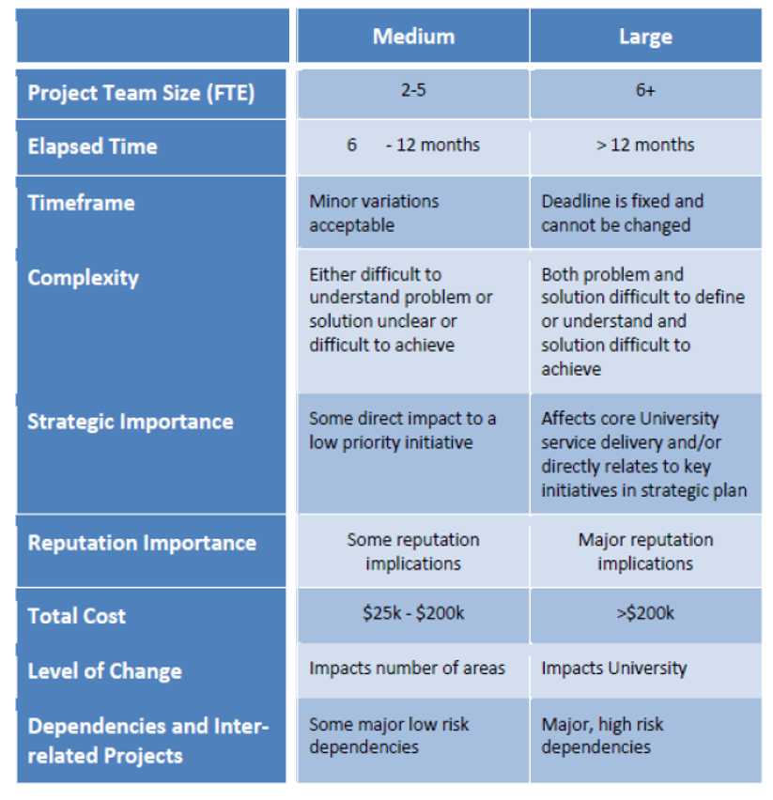

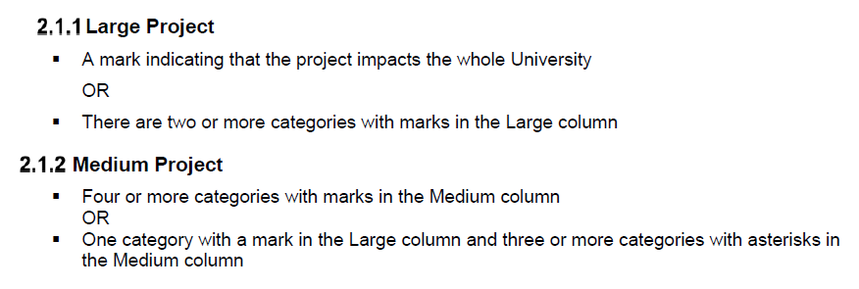

1. Project Management Institute (PMI) definition from The Standard for Program Management—Second edition (PMI, 2008b, p. 312).