Subject: Have your say – feedback on your unit [unit code – unit title]

Dear [name]

[unit code unit name]

[if this is a reminder/followup …]
Recently we asked you to participate in an evaluation survey of [Unit Code – Unit Title]. If you have already responded, thanks! If not please read on.

We are seeking information from you about this unit and its teaching. We value your feedback as we use it to improve the quality of the unit and its teaching.

Please complete the online UTEI questionnaire any time between [start date] and [end date].

To access your UTEI survey for this unit, please go to the student portal and look under Useful Links. Click on the ‘UTEI Surveys’ link (you may be asked to login a second time).

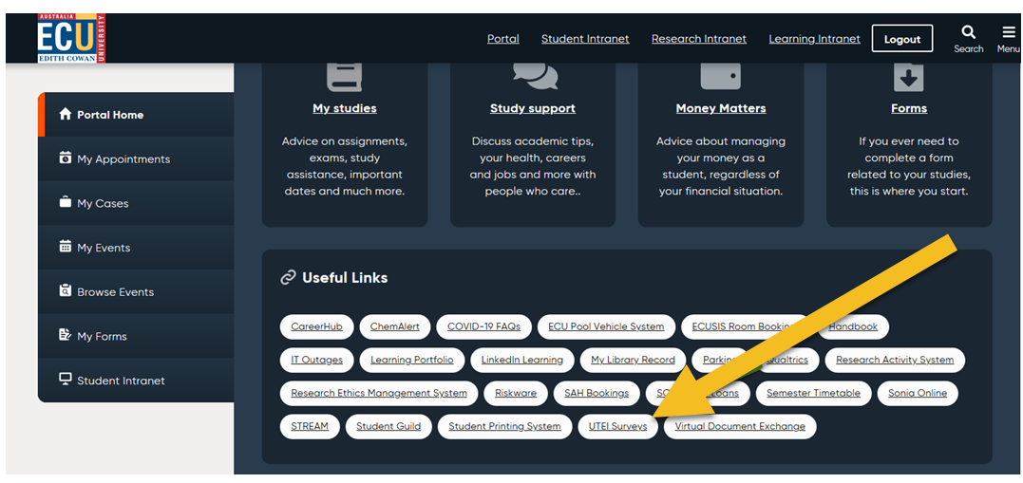

You will be presented with one or more units that have been selected by your School for evaluation via this particular portal mode. You will also see, for each unit, a dropdown list of lecturers and/or tutors selected by your School for evaluation.

First, select the unit and answer the items on the basis of your experience with the unit. When you are ready, click submit to submit your information.

Next, do likewise after selecting each relevant teacher. When you have finished, logout and close the browser.

Your feedback will remain confidential, and no student names or IDs will be reported next to the summarised results.

Should you have any concern about any aspect of this online UTEI evaluation, please let me know, or email surveys@ecu.edu.au

Name
School
Ext or Email

Please note: for most units, UTEIs are administered using a different survey tool (Qualtrics) which has a different look/feel. The student portal-based tool referred to here is an alternative tool which is occasionally used for greater flexibility.

