Guide to Searching on the Legislation, Policy and Governance Documents Directory

- Access the Legislation, Policy and Governance Documents Directory. The Directory opens to a front page listing all documents in alphabetical order.
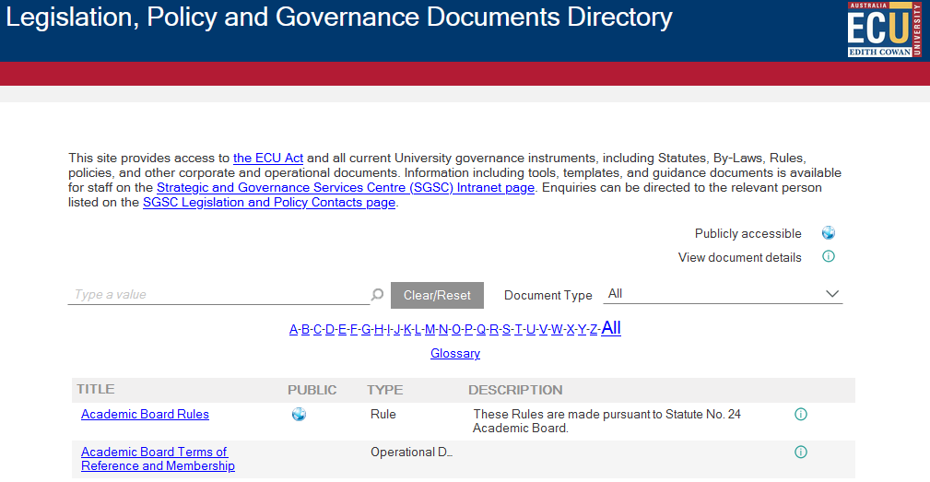

- To search, select the ‘Type a Value’ field. This search function is not case sensitive and can search for keywords and partial words. Word that are searched will be highlighted yellow in the results.
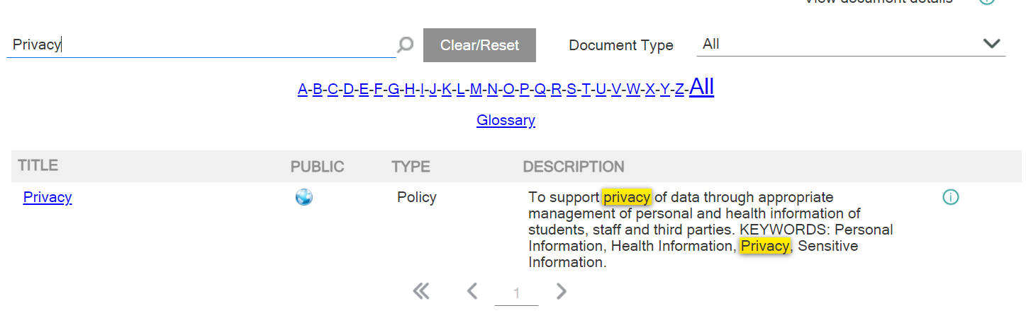

- Refine results by using the Document Type filter. There are options for ‘ECU Act’, ‘Statute’, ‘By-Laws’, ‘Rule’, ‘Policy’, ‘Corporate Governance Document’ or ‘Operational Document’.
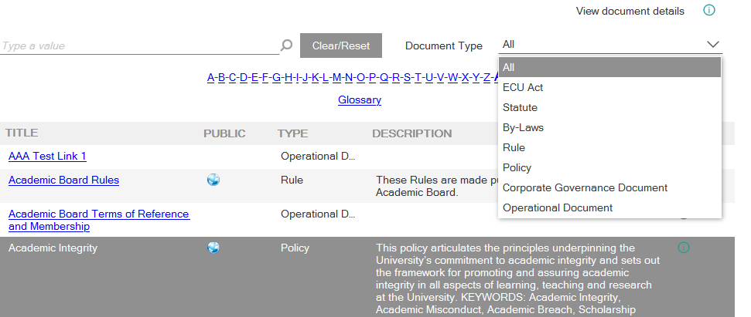

- Filter the results further by selecting a letter on the alphabetical tool. This will filter to display all documents commencing with the selected letter.

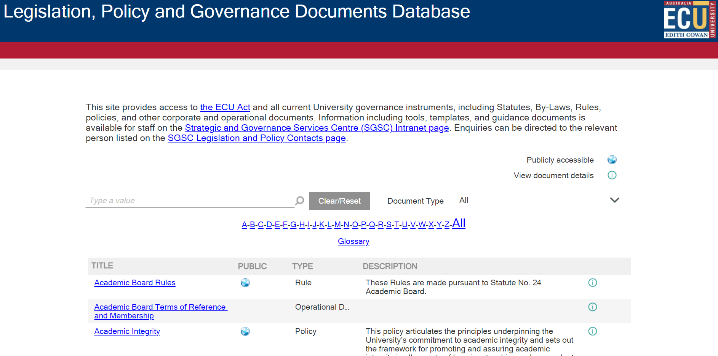

- Click Glossary, this document refers to the University Glossary. The purpose of this glossary is to harmonise the use of keywords and phrases across University Rules, By-Laws, policies, and operational documents (Governance Documents) to ensure consistency of use and enhance readability.

- Documents are classified as Publicly Available with the world symbol. Every document has an information button for document details.
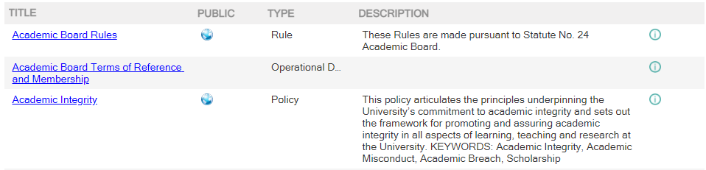
- Open the document details by pressing the green information button.
- A new pane will load displaying the details of the document, such as Document Type, Document Owner, Enquiry Contacts, and Related Documents. The Related Documents can be accessed by clicking on their hyperlinks.
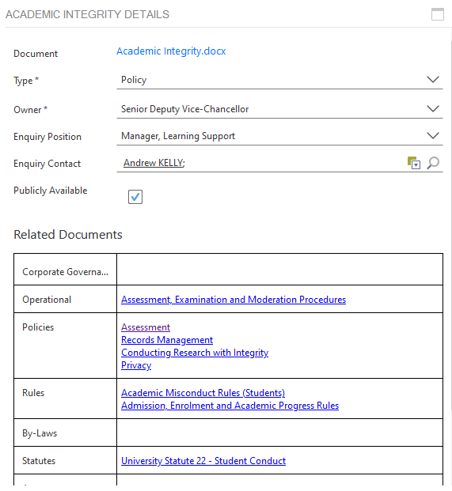

- Pressing the Clear/Reset button will remove all the search filters previously entered.
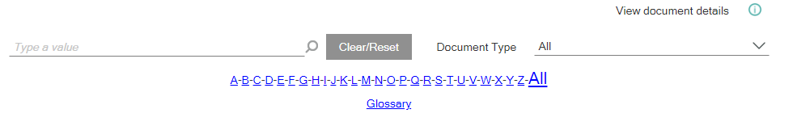

Version Control
Date | Version | Author | Approval
25 January 2022 | Version 1.0 | Heather Jowett | Mark Ridgwell
11 April 2022 | Version 2.0 | Leonie Nel | Karen McFarland

