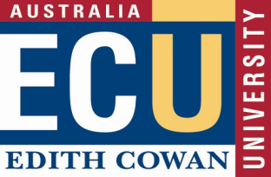
Probation Outcome Form
Action for Line Manager/Supervisor: Please complete and return this form to Payroll no later than four (4) weeks prior to the end of the probationary period. This is to be completed once a final decision has been made.
Employee Information
Employee Name |  | Employee Number
Position title |  | Position Number
Probation End Date |  | Appointment End date
Classification |  | Employee Status
Increment level |  | Line Manager
School/Centre
Recommendation – Please tick one of the following:
CONFIRM APPOINTMENT

I confirm that formal discussions have been held with the staff member identified above on the requirements for confirmation of appointment (as stated in the Probation Outcome Letter, and in accordance with the Edith Cowan University Enterprise Agreement) and future goals and expectations have been clearly established and documented.

TERMINATE EMPLOYMENT

In considering Termination of Employment, please contact your Business Partner.
Note: Extension of Probation requires endorsement from the Director, People and Culture and the Line Executive.

Attach all supporting documentation to this form prior to processing and record keeping.

Employee Signature: |  | Name:  Date:
Line Manager/Supervisor Comments
Line Manager/Supervisor Signature: |  | Name:  Date:
Approval
Line Executive Signature: |  | Name:  Date:
*Upon completion, please forward a copy to Payroll Services for processing and record keeping.

