How to Create a Hyperlink to a Policy, By-Law, Statute, or Rule

This guide outlines how to retrieve a direct link to a document stored within the Legislation, Policy and Governance Documents Directory.

The process for copying links in the Legislation, Policy and Governance Documents Directory is different to how it was done in the previous Legislation and Policy Search. The simplest way to copy a link is outlined below.

Linking to a Policy, By-Law, Statute, or Rule

- Open the Directory and select the paperclip icon to the right of the document that you need to create a link to:

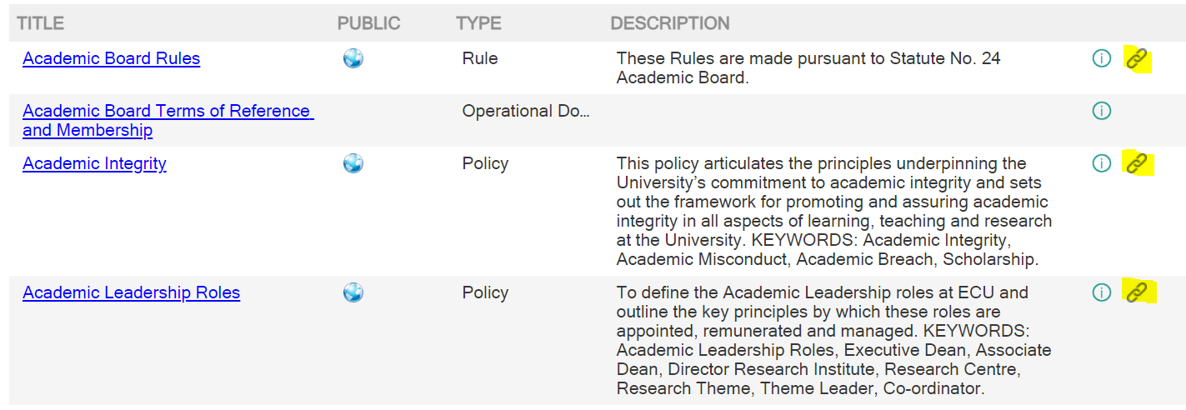

- Left click on the paperclip icon to generate the link:

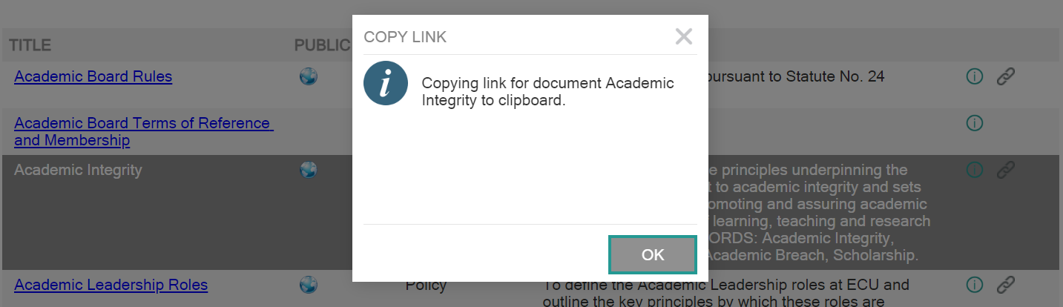

- Left click on the ‘OK’ button. This will copy the link to the Clipboard:

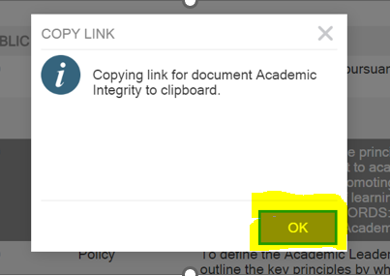

- The link can now be pasted into your document or email. You may need to right click the hyperlink and select “Edit Hyperlink’ to correctly name the link:

Version Control
Date | Version | Author | Approval
25 January 2022 | Version 1.0 | Heather Jowett | Mark Ridgwell
5 April 2022 | Version 2.0 | Roma Fragomeni | Karen McFarland
11 April 2022 | Version 3.0 | Heather Jowett | Karen McFarland
24 January 2023 | Version 4.0 | Karen Van Staden | Karen McFarland
12 September 2023 | Version 5.0 | Karen McFarland | Karen McFarland

