POLICY TEMPLATE

If you do not have a copy of the Policy Template, please email policy@ecu.edu.au. Policies will not be progressed for approval if they do not use the correct format.

POLICY TITLE

The policy title should not start with ‘ECU’ or ‘University’.

HYPERLINKS

The beginning of the policy document has hyperlinks that redirect to relevant sections within the document. This has been pre-formatted into the Policy Template document; to keep these links active, do not adjust the headers or bookmarks.

FONT

The policy should be written using Arial, size 11 font with paragraph spacing set at zero both before and after.

ALIGNMENTS & INDENTATIONS

All alignments and indentations are preformatted on the document; however, in the case of accidental changes, images are included below to identify the correct spacing.

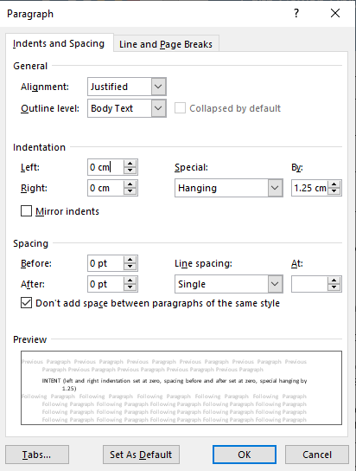

The only exception to this is for sub-clauses. Read the section below on Policy Content for details.

INTENT, ORGANISATIONAL SCOPE, & DEFINITIONS

These sections are all formatted the same way. Each paragraph should be separated with a single line. Individual paragraphs are not numbered or marked. Two single line spaces are used before a new heading.

TABLES

All tables, including the definitions and contacts, use spacing of 3pt before and after.

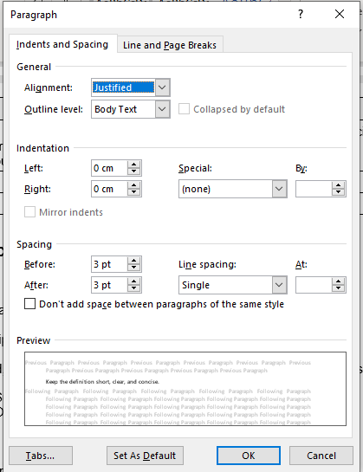

DEFINITIONS

Choose one of the two introductory sentences from the Policy Template to include in the section. The definitions table is set to repeat the headings of the table if it goes over a page break. Ensure the words in the left-hand column are left aligned and the words in the right-hand column are justified.

Before adding a word to the Definitions section, check the Glossary. If the word is already defined, but the meaning is different to the intent required for the policy, then try to find an alternative term and provide a new definition more aligned to the intended meaning. Only if there is no other acceptable alternative term is it possible to redefine the term in the policy definition section to suite the document.

POLICY CONTENT

Use the sub-header layout only if it is necessary to group clauses. Ensure only a single line space is between the section header and sub-header.

Sub-header format:

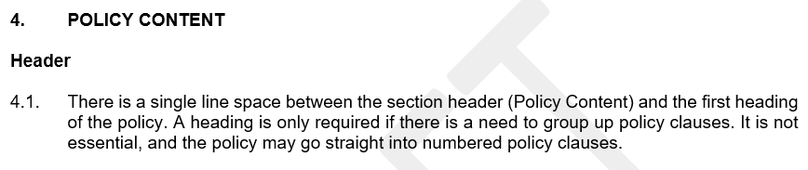

No sub-header:

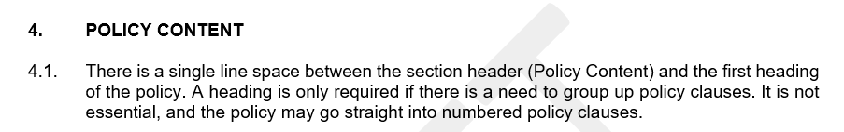

Sub-clauses:

For sub-clauses, only a single line break is used to separate them from primary policy clauses. Sub-clause lists are indented, alphabetic lists. A semi-colon is used to end each sub-clause apart from the final one, where a full stop is used instead. Sub-clauses can use ‘and’/’or’ to show interdependencies in clauses.

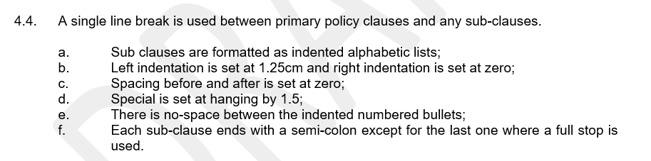

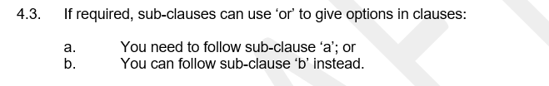

If something occurs to change the formatting of the policy content, then please use the following:

- The indentation settings for the headers which group up policy clauses are zero for both left and right. Spacing is also zero for both before and after. The settings for ‘special’ are (none).
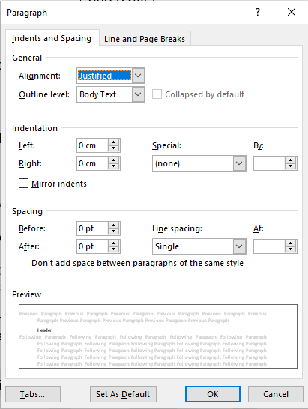

- The high-level numbered policy clauses (for example 4.1, 4.2 etc) are set at zero for indentation and spacing the same as the policy clause headers. The settings for ‘special’ are hanging by 1.25.
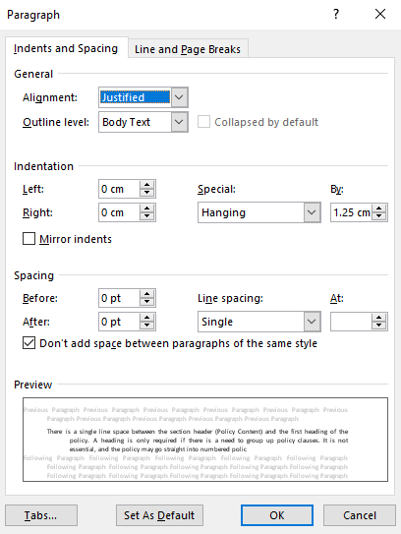

- The sub-clauses have a left indentation of 1.25 and a right indentation of zero. The spacing is the same as the policy clause headers. The settings for ‘special’ are hanging by 1.5. There is no space between the indented, alphabetic points.

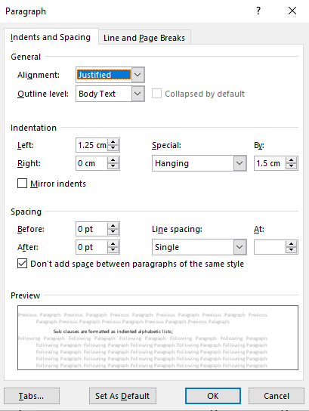

ACCOUNTABILITIES & RESPONSIBILITIES

The policy template has standard wording for this section that must be used. This section is formatted the same as the Intent section: a single line space between paragraphs, same indentations, and no bullet points or numbering.

RELATED DOCUMENTS

This section has a single line space between paragraphs and no bullet points or numbering.

The sub-headers are formatted the same as the sub-headers used in the Policy Content section. Delete any sub-headers that don’t relate to the policy.

Ensure related documents are, as far as possible, included as hyperlinks.

CONTACT INFORMATION

If a policy will have multiple contacts for enquiries, ask for advice from the Senior Advisor on how to present this.

FOOTER

Include the policy code and title. Add the month and year of revision.

