Known trialled rubrics prepared and trialled Semester 2 2019.
Included are Rubrics either trialled in 2019 and or used in 2020, with notes where applicable to demonstrate flexibility over levels and over disciplines.
- Appendix 1A: SAH: UG: Demonstrated level: Written rubric Research Essay Grading Rubric. First trial 2019
- Appendix 1B: SAH: UG: Demonstrated level: Written rubric Oral Presentation and Written Film Review Grading Rubric. Second trial 2019
- Appendix 1C: SAH: UG: Demonstrated level: Written rubric Final Research Essay Grading Rubric. Third trial 2019
- Appendix 2A: SENG: PG: Introduced level: Written rubric Individual draft report (marked by literacy specialists).
- Appendix 2B: SENG: PG: Introduced level: Written rubric Group report (marked by Discipline academics).
- Appendix 3A: SOE: UG: Demonstrated level: Oral presentation rubric
- Appendix 3B: SOE: UG: Demonstrated level: 2019 Assignment 1
  - These are the two Education units that adopted a modified version of the Communication skills rubric. These were used in Semester 2 2020.
  - Bachelor of Education (Secondary): unit mapped at Demonstrated level, rubric used for written and oral communication skills
  - School Based Professional Learning – Internship. This elective final year unit is not mapped as a communications skills milestone unit; rubric used to assess oral communication skills.
- Appendix 4A: SMHS:UG: Introduced level:– Assignment Rubric (annotated bibliography x3 900 words and reflection 100 words)
- Appendix 4B: SMHS: UG: Introduced level: Oral :Crew Presentation Rubric
  - The communication skills rubric was trialled in first year unit to assess written and oral communication skills at an introductory level.
  - The assessments were a research task (an annotated bibliography and written reflection) and a group presentation. The feedback from the lecturer was very positive.
Appendix 1A: SAH: UG: Demonstrated level: Written (with Oral component) Analytical Research Essay Grading Rubric. Trialled 2019
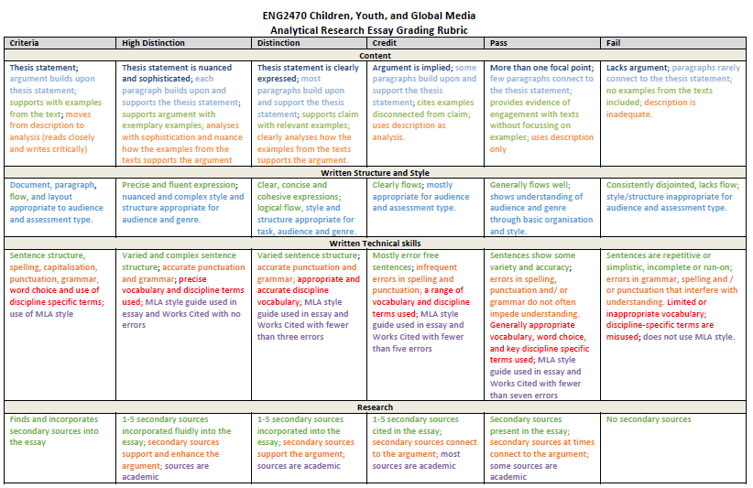

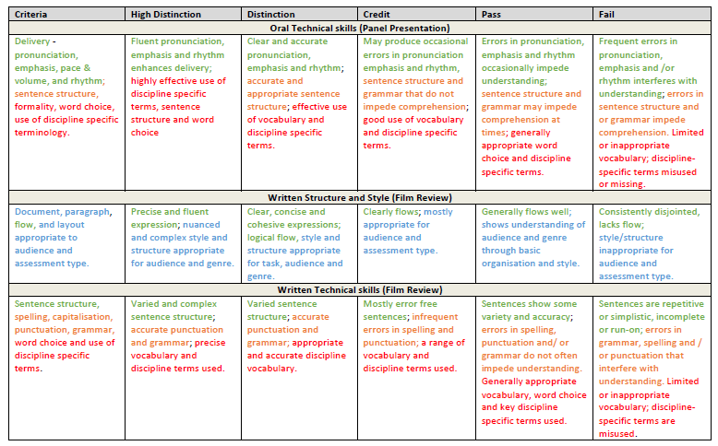
Appendix 1B: SAH: UG: Demonstrated level: Written rubric Oral Presentation and Written Film Review Grading Rubric. Second trial 2019
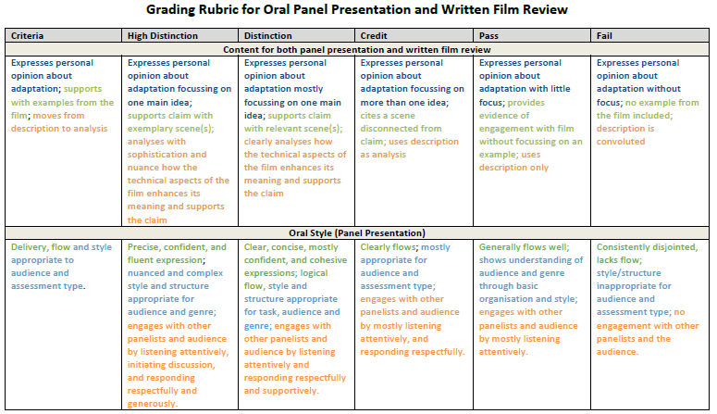

Appendix 1C: SAH: UG: Demonstrated level: Written rubric Final Research Essay Grading Rubric

Criteria | High Distinction | Distinction | Credit | Pass | Fail
Content
Thesis statement; paragraphs build upon thesis statement; supports argument with examples from the text; moves from description to analysis (reads closely and writes critically) | Thesis statement is nuanced and sophisticated; each paragraph builds upon and supports the thesis statement or implied argument; supports argument with exemplary examples; analyses with sophistication and nuance how the examples from the texts support the argument. | Thesis statement is clearly expressed; most paragraphs build upon and support the thesis statement or implied argument; supports argument with relevant examples; clearly analyses how the examples from the texts support the argument. | Argument is implied or descriptive; some paragraphs build upon and support the thesis statement or the implied argument; cites examples related to implied or descriptive argument; uses description as analysis. | More than one focal point; few paragraphs connect to the thesis statement or the implied argument; provides evidence of engagement with texts without focussing on examples; uses description only. | Lacks argument; paragraphs rarely or do not connect to the thesis statement or implied argument; no examples from the texts included; description is inadequate.
Written Structure and Style
Document format, paragraph, flow within and between paragraphs, and layout appropriate to audience and assessment type. | Essay formatted using MLA guidelines; paragraphs unified around a clear topic sentence; flows smoothly within and between paragraphs; nuanced and complex style and structure appropriate for audience and genre. | Essay formatted using most MLA guidelines; most paragraphs unified around a clear topic sentence; good flow within and between paragraphs; style and structure appropriate for task, audience, and genre. | Essay formatted using some MLA guidelines; most paragraphs unified around one topic; some attention to flow within and between paragraphs; style and structure mostly appropriate for audience and assessment type. | Essay formatted using a few MLA guidelines; some paragraphs unified around one topic; flows well at times; shows understanding of audience and genre through basic organisation and style. | Essay not formatted using MLA guidelines; paragraphs consistently contain more than one topic; consistently disjointed, and lacks flow; style/structure inappropriate for audience and assessment type.
Written Technical skills
Sentence structure, spelling, capitalisation, punctuation, grammar, word choice and use of discipline specific terms; use of MLA style. | Varied and complex sentence structure; accurate punctuation and grammar; precise vocabulary and discipline terms used; MLA style guide used in essay and Works Cited with no errors. | Varied sentence structure; accurate punctuation and grammar; appropriate and accurate discipline vocabulary; MLA style guide used in essay and Works Cited with fewer than three errors. | Mostly error free sentences; infrequent errors in spelling and punctuation; a range of vocabulary and discipline terms used; MLA style guide used in essay and Works Cited with fewer than five errors. | Sentences show some variety and accuracy; errors in spelling, punctuation and/ or grammar do not often impede understanding. Generally appropriate vocabulary, word choice, and key discipline specific terms used; MLA style guide used in essay and Works Cited with fewer than seven errors. | Sentences are repetitive or simplistic, incomplete or run-on; errors in grammar, spelling and / or punctuation that interfere with understanding. Limited or inappropriate vocabulary; discipline-specific terms are misused; does not use MLA style.
Research
Finds and incorporates secondary sources into the essay. | 1-5 secondary sources incorporated fluidly into the essay; secondary sources support and enhance the argument; sources are academic. | 1-5 secondary sources incorporated into the essay; secondary sources support the argument; sources are academic. | 1-5 secondary sources cited in the essay; secondary sources connect to the argument; most sources are academic. | Secondary sources present in the essay; secondary sources at times connect to the argument; some sources are academic. | No secondary sources

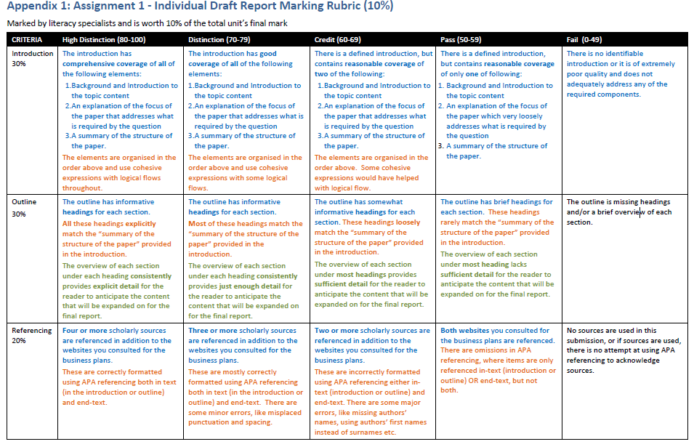
Appendix 2A: SENG: PG: Introduced level: Written rubric (marked by literacy specialists) Assignment 1 – Individual Draft Report Marking Rubric (10%)

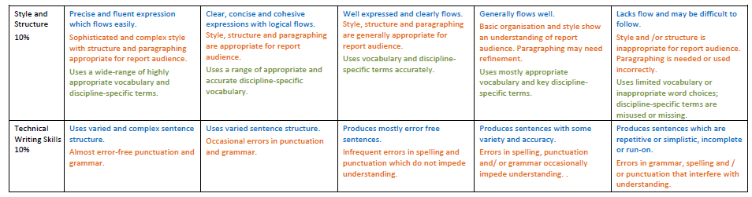

Appendix 2B: SENG: PG: Consolidated level: written rubric marked by Discipline academics.
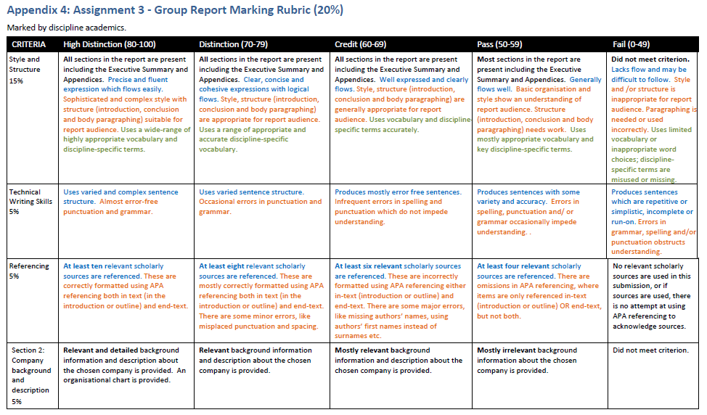

Appendix 3A: SOE: UG: Demonstrated level: Oral presentation rubric
PRESENTATION CONTENT
CRITERIA | Outstanding |  |  | Very good | Satisfactory |  | Unsatisfactory | Very poor | Not demonstrated |  | Score
Overview of the engagement activity | Clearly articulated and in-depth explanation to the audience. Including the need to be involved and how the involvement impact both the professional development of the preservice teacher and school |  |  | Very good explanation, including an outline of school need and how the engagement benefitted school and preservice teacher | Satisfactory explanation giving an outline of the activity and how it benefitted the school and or preservice teacher |  | Explanation was brief giving some outline of the activity and why school needed preservice teacher involvement | Very brief explanation of the activity with little outline of school needs addressed. | Section not addressed |  | 20
Conceptualisation of school complexity | Highly sophisticated presentation, clearly elaborated and explained so that the audience comprehensively understands the topic. |  |  | Effectively presented so that the audience clearly understands the topic. | Satisfactory presentation ensuring that the audience understands most of the topic. |  | At times the presentation lacked clarity for ease of understanding by the audience | Unsatisfactory presentation that is totally confusing. | Inappropriate presentation. |  | 20
Critical Analysis and articulation policy enactment within a school in particular with the engagement activity | Highly sophisticated and explicit analysis of the policies that governed the school and their implementation into school structure and activities  Clear and articulate definition of policy enactments. |  |  | Effective analysis of the policies that were implemented in the schools’ activities. A clear definition of policy enactments. | Satisfactory analysis outlining the policies that teachers know to be involved in school activity and structure and a brief definition of policy enactment. |  | Low level of analysis outlining policies that govern schools, or unclear analysis of implementation. Limited understanding demonstrated about policy enactments. | Unsatisfactory analysis of policy implementation and policy enactment | Analysis not completed or presented. |  | 20
ORAL DELIVERY OF PRESENTATION
Structure and style (oral communication skills):  Delivery, flow and style appropriate to audience and assessment type. Formality, word choice, use of discipline specific terminology | Precise and fluent expression;  Nuanced and complex style and structure appropriate for audience and genre. Highly effective use of discipline specific terms, sentence structure and word choice |  | Clear, concise and cohesive expressions; logical flow;  Style and structure appropriate for task, audience and genre. Effective use of vocabulary and discipline specific terms |  |  | Clearly flows;  Appropriate for audience and assessment type.  Good use of vocabulary and discipline specific terms | Generally flows well;  Shows understanding of audience and genre through basic organisation and style.  Generally appropriate word choice and discipline specific terms | Does not flow well and  difficult to follow;  Style/structure inappropriate for audience and assessment type.  Limited or inappropriate vocabulary; discipline specific terms misused or missing |  |  | 10
Mechanics style (oral communication skills):  Delivery - pronunciation, emphasis,  pace & volume, and rhythm;  sentence structure and grammar | Fluent pronunciation, emphasis and rhythm enhances delivery;  Accurate and appropriate sentence structure. |  | Clear and accurate pronunciation, emphasis and rhythm;  Accurate and appropriate sentence structure with minimal grammatical errors. |  |  | May produce occasional errors in pronunciation emphasis and rhythm;  Sentence structure and grammar that do not impede comprehension. | Errors in pronunciation, emphasis and rhythm occasionally impede understanding;  Sentence structure and grammar may impede comprehension at times. | Frequent errors in pronunciation, emphasis and /or rhythm interferes with understanding;  Errors in sentence structure and or grammar impede comprehension. |  |  | 10
Professionalism and non-verbal communication | Professionally attired, strong presentation in a control manner, confident and competent throughout the entire duration of the presentation. |  | Professionally attired, very well -prepared, confident and competent for most of the presentation. |  |  | Professionally attired but wavers in confidence and competence throughout the presentation. | Inappropriately attired but is confident and competent. | Inappropriately attired and is competent but not confident. |  | Inappropriately attired and is neither competent nor confident. | 10
PROFESSIONALISM of PPT – will be marked separately
Critical appraisal of relevant literature and synthesis of theory, research, and practice (assessed by coordinator from submitted ppt) |  | Excellent use of a large range of appropriate, reliable and scholarly literature to critically support the thesis. | A range of appropriate, reliable and scholarly literature was used to support the presentation. |  |  | A range of literature was used but some were not considered scholarly and/or reliable sources to support the presentation. | Minimal amount of literature was used, but not all are considered scholarly and/or reliable sources to support the presentation. | Poor quality of literature or no appropriate literature utilised to support the presentation. | Appraisal not based on literature |  | 10
TOTAL MARKS |  |  |  |  |  |  |  |  |  |  | 100
Appendix 3B: SOE: UG: Demonstrated level: 2019 Assignment 1 Oral presentation rubric
2019 Ass 1 | Criteria | Exemplary 4.5 | Excellent 4 | Very good 3.5 | Satisfactory 3 | Just competent 2.5 | Needs improvement 2
GROUP  (Part 1):  TOPIC PLANNING SCHEDULE  (out of 30 possible marks) | Cohesion: Clarity and organisation of learning activities
 | Scaffolding of learning activities in the topic plan, showing attention to student diversity
 | Level of difficulty of lessons and tasks, appropriate for the chosen year cohort; pace and timing
 | Accuracy and appropriateness of mathematical content
 | Resources: Appropriateness of resources chosen
 | Senior schooling curriculum: demonstrated understanding of the concepts as they occur in the Year 11 scope and sequence for the subject; demonstrated understanding of the relevant ATAR subject content descriptions
INDIVIDUAL  (Parts 2 and 3):  (out of 30 possible marks) | Literature review
 | Analysis of resources
 | Analysis and depth of notes on teaching
 | Reflection on observed teaching, using notes from classes
 | Structure and style (written communication skills):  Flow and layout appropriate to audience and assessment type | Professional, precise and fluent expression which flows easily.  Highly sophisticated and complex structure and style appropriate for audience and assessment type. | Precise and fluent expression which flows easily;  Sophisticated and complex structure and style appropriate for audience and assessment type. | Clear, concise and cohesive expressions; logical flow;  Style and structure appropriate for task, audience and assessment type  . | Well expressed and clearly flows;  Style and structure generally appropriate for audience and assessment type. | Flows well;  Shows understanding of audience and assessment type through basic organisation and style. | Does not flow well and difficult to follow;  Style and/or structure is inappropriate for audience and assessment type.
 | Mechanics style (written communication skills):  Sentence structure; Spelling, punctuation, and grammar | Varied and highly sophisticated sentence structure.  Rare errors in punctuation and grammar. | Varied and complex sentence structure;  Almost error-free punctuation and grammar. | Varied sentence structure; Occasional errors in punctuation and grammar. | Mostly error free sentences;  Infrequent errors in spelling and punctuation which do not impede understanding. | Sentences show some variety and accuracy;  Errors in spelling, punctuation and/ or grammar occasionally impede understanding.  . | Sentences are repetitive or simplistic, incomplete or run-on;  Errors in grammar, spelling and / or punctuation that interfere with understanding.
 | FINAL TOTAL (60)

APPENDIX 4A: SMHS: UG: Developing level – Assignment Rubric (annotated bibliography x3 900 words and reflection 100 words)
Criteria | High Distinction  Excels in all requirements  80%+ | Distinction  Excels in some and exceeds all requirements  70 – 79% | Credit  Exceeds minimum requirements  60 – 69% | Pass  Meets minimum requirements  50 – 59% | Fail  Not yet meeting minimum requirements  49% - 0%
Content

Bibliographic details for each annotation:  Complete bibliographic information, correct APA format. | Full bibliographic details for each source, correctly formatted in APA style | Full bibliographic details for each source, minor formatting errors | Bibliographic details for each source, minor omissions and formatting errors | Bibliographic details for each source, some omissions and errors in formatting | Incomplete bibliographic details, significant errors in formatting
Descriptive paragraph  Accurate summary of key ideas of the source. | Comprehensive, concise and accurate summary of key ideas. Provides a useful overview of source. | Concise and accurate summary of key ideas. Provides a useful overview of source. | Clear and largely accurate summary of key ideas. Provides a general overview of source. | Basic summary of key ideas. Provides a limited overview of source. | Limited summary, does not provide a useful overview of source.
Evaluative paragraph  Useful analysis of the credibility, reliability and usefulness of the source. | Comprehensive and insightful analysis of the credibility, reliability and usefulness of the source. | Insightful analysis of the credibility, reliability and usefulness of the source. | Useful analysis of the credibility, reliability and usefulness of the source. | Limited analysis of the credibility, reliability and usefulness of the source. | Inadequate analysis of the credibility, reliability and usefulness of the source.
Personal reflection  Insightful reflection, evidence of insight | Concise and insightful reflection, clear evidence of engagement with the task | Insightful reflection, clear evidence of engagement with the task | Reflection shows evidence of insight and engagement with the task | Reflection shows some evidence of insight and engagement with the task | Reflection lacks insight and limited evidence of engagement with the task
Written Communications
Style and structure:  Flow, expression, paragraphing and structure appropriate to audience and assessment type.  Vocabulary, word choice and use of discipline specific term are appropriate for audience and purpose. | Precise and fluent expression which flows easily. Sophisticated and complex style with structure and paragraphing appropriate for audience and assessment type.  Uses a wide-range of highly appropriate vocabulary and discipline-specific terms. | Clear, concise and cohesive expressions with logical flows. Style, structure and paragraphing are appropriate for task, audience and assessment type. Uses a range of appropriate and accurate discipline-specific vocabulary. | Well expressed and clearly flows. Style, structure and paragraphing are generally appropriate for audience and assessment type.  Uses vocabulary and discipline-specific terms accurately. | Generally flows well.  Basic organisation and style show an understanding of audience and assessment type. Paragraphing may need refinement.  Uses mostly appropriate vocabulary and key discipline-specific terms. | Lacks flow and may be difficult to follow. Style and /or structure is inappropriate for audience and assessment type. Paragraphing is needed or used incorrectly.  Uses limited vocabulary or inappropriate word choices; discipline-specific terms are misused or missing.
Technical skills  Sentence structure is varied and complex, Spelling, punctuation, and grammar are accurate and communicate intended meaning. | Uses varied and complex sentence structure.  Almost error-free punctuation and grammar. | Uses varied sentence structure. Occasional errors in punctuation and grammar. | Produces mostly error free sentences.  Infrequent errors in spelling and punctuation which do not impede understanding. | Produces sentences with some variety and accuracy.  Errors in spelling, punctuation and/ or grammar occasionally impede understanding. . | Produces sentences which are repetitive or simplistic, incomplete or run-on.  Errors in grammar, spelling and / or punctuation that interfere with understanding.
APPENDIX 4B: SMHS: UG: Developing level - Crew Presentation Rubric
Criteria | High Distinction  Excels in all requirements  80%+ | Distinction  Excels in some and exceeds all requirements  70 – 79% | Credit  Exceeds minimum requirements  60 – 69% | Pass  Meets minimum requirements  50 – 59% | Fail  Not yet meeting minimum requirements  49% - 0%
Content:  Comprehensive understanding of topic,  well researched, excellent information and approach | Presentation and resource articulates a comprehensive understanding of the chosen topic, well researched with excellent information and approach with alternatives. | Presentation and resource demonstrates a clear level of understanding about the chosen topic, well researched with good information and approach with alternatives. | Presentation and resource demonstrates a clear understanding of the chosen topic, researched with clear information and approach. | Presentation and resource demonstrates understanding of the chosen topic, with some research, information and an approach. | Presentation and resource contains several content errors impacting the overall message.
Oral communications:  Structure is appropriate to task type.  Communication is clear, fluent and confident.  Verbal and non-verbal skills are appropriate to audience and purpose.  Formality, word choice and use of discipline specific terminology is appropriate and accurate. | Shows strong understanding of appropriate structure.  Communicates ideas clearly, fluently and with ease throughout the presentation.  Uses a wide range of highly effective verbal and non-verbal communication skills and strategies that are very well -suited to the audience and purpose.  Use of language is highly appropriate and accurate and enhances communication. | Shows good understanding of appropriate structure  Communicates ideas clearly, fluently and with ease throughout most of the presentation.  Uses a good range of effective verbal and non-verbal communication skills and strategies that are well -suited to the audience and purpose.  Use of language is very appropriate and accurate and enables communication. | Shows understanding of appropriate structure.  Communicates ideas clearly and fluently throughout much of the presentation.  Uses a range of effective verbal and non-verbal communication skills and strategies that suit the audience and purpose.  Use of language is appropriate and accurate. | Shows some understanding of appropriate structure.  Communicates clearly throughout most of the presentation.  Uses a range of effective verbal and non-verbal communication skills and strategies that may not be entirely suited to audience and purpose.  Use of language is mostly appropriate and accurate. | Does not show understanding of appropriate structure.  Does not communicate clearly due to errors in pronunciation, emphasis and /or rhythm, which interfere with understanding.  Uses verbal and non-verbal communication skills and strategies that are not suited to audience and purpose.  Use of language is inappropriate and/ or inaccurate.
Teamwork:  Equal contribution from all crew members in the presentation  Evidence of equal contribution from all crew members in the timeline  Evidence of planning for the project in the timeline | Team members contributed equally to the presentation  There is extensive evidence of project planning  There is extensive evidence of planning for the project | Team members contributed equally to the presentation  There is detailed evidence of project planning  There is detailed evidence of planning for the project | Team members contributed equally to the presentation  There is clear evidence of project planning  There is clear evidence of planning for the project | Team members contributed equally to the presentation  There is limited evidence of project planning  There is limited evidence of planning for the project | Team members did not contribute equally to the presentation  There is no evidence of project planning  There is no evidence of planning for the project

