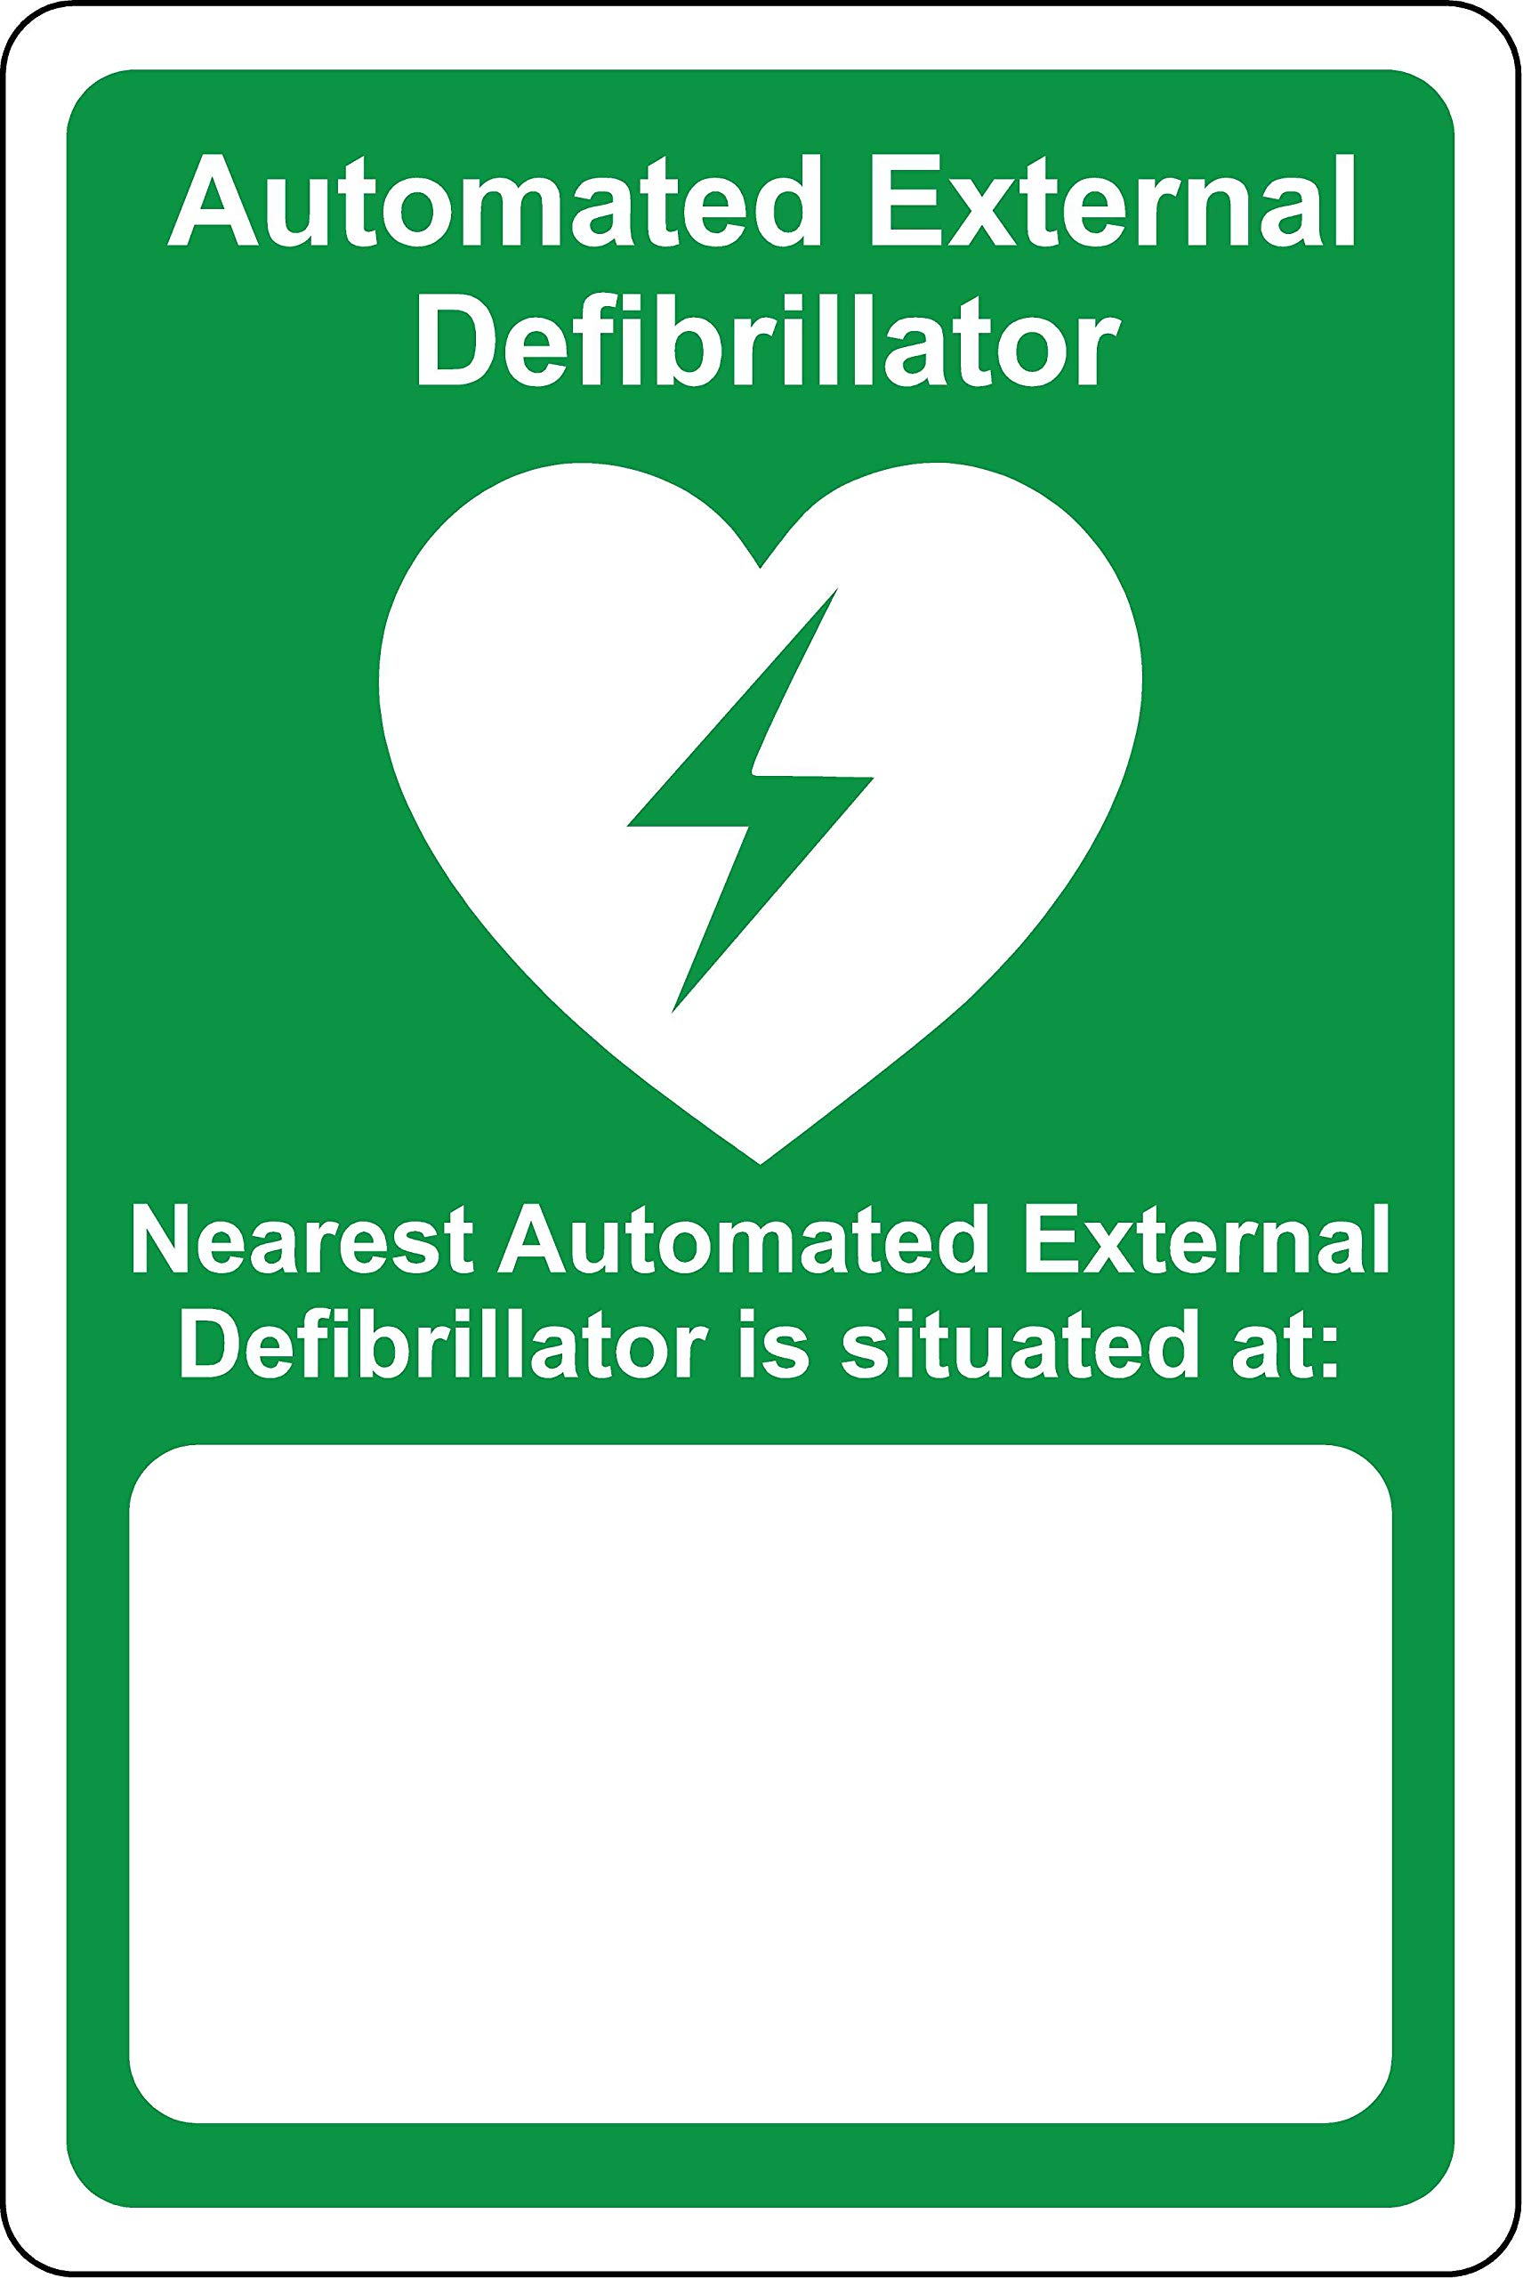

**In a medical emergency, call Emergency   
Services on 000 then ECU Security on 6304 3333**

\*Insert Location here\*  
(Building, Level, Room)