**Skills and Knowledge Audit/Plan**

**Early Candidature**

The Higher Degree by Research (HDR) Learning Plan is a structured planning tool that supports Higher Degree by Research candidates in their professional development. The tool assists candidates to audit and plan their professional development across various domains relevant to their research, course learning outcomes and career.

The HDR Learning Plan is aligned with ECUs [Researcher Professional Development Framework (RPDF)](https://edithcowanuni.sharepoint.com/sites/RS-ResearcherProfessionalDevelopment/SitePages/Researcher-Professional-Development-Framework.aspx) which is organised into four separate domains, as outlined below:

* [Personal and Professional Development](https://intranet.ecu.edu.au/research/for-research-staff/researcher-professional-development-at-ecu/researcher-professional-development-framework/personal-and-professional-development)
* [Research Skills](https://intranet.ecu.edu.au/research/for-research-staff/researcher-professional-development-at-ecu/researcher-professional-development-framework/research-skills)
* [Research Governance](https://intranet.ecu.edu.au/research/for-research-staff/researcher-professional-development-at-ecu/researcher-professional-development-framework/research-governance)
* [Engagement and Impact](https://intranet.ecu.edu.au/research/for-research-staff/researcher-professional-development-at-ecu/researcher-professional-development-framework/engagement-and-impact)

**Completing your HDR Learning Plan**

Completion of the HDR Learning Plan is a requirement of Milestone 1. Candidates are strongly encouraged to revisit their learning plan at each milestone and/or Progress Report.

Each candidates’ prior learning, experience and needs will differ. The Graduate Research Learning Plan provides an opportunity for candidates to take ownership of their own learning and unique research journey. The HDR Learning Plan should be established in collaboration with your supervisors and revisited throughout your research journey. When developing your Learning Plan candidates should consider the following:

1. **Self-assessment** of skills and knowledge
2. **Consult** **and confirm** with supervisors, advisors, mentors and others
3. **Plan/Record** activities to further improve and enhance learning
4. **Revisit** the Learning Plan throughout your candidature

Stage 1:  **Self-assessment** of skills and knowledge

1. Candidates are encouraged to audit and evaluate their current skills and knowledge relevant to the degree and career.
2. Candidates should consider the skills required to complete their research and course, as well as the skills and knowledge needed within their career.
3. Consider strengths, priorities, areas to develop, opportunities and obstacles important to your research and development.

Candidates are required to complete a self-assessment of their current skills and knowledge relevant to their research. The ECU Researcher Professional Development Framework Planner (screen shot below) provides a useful tool to assist.

An editable version of the Planner can be downloaded from the [RPDF home page](https://edithcowanuni.sharepoint.com/sites/RS-ResearcherProfessionalDevelopment/SitePages/Researcher-Professional-Development-Framework.aspx).

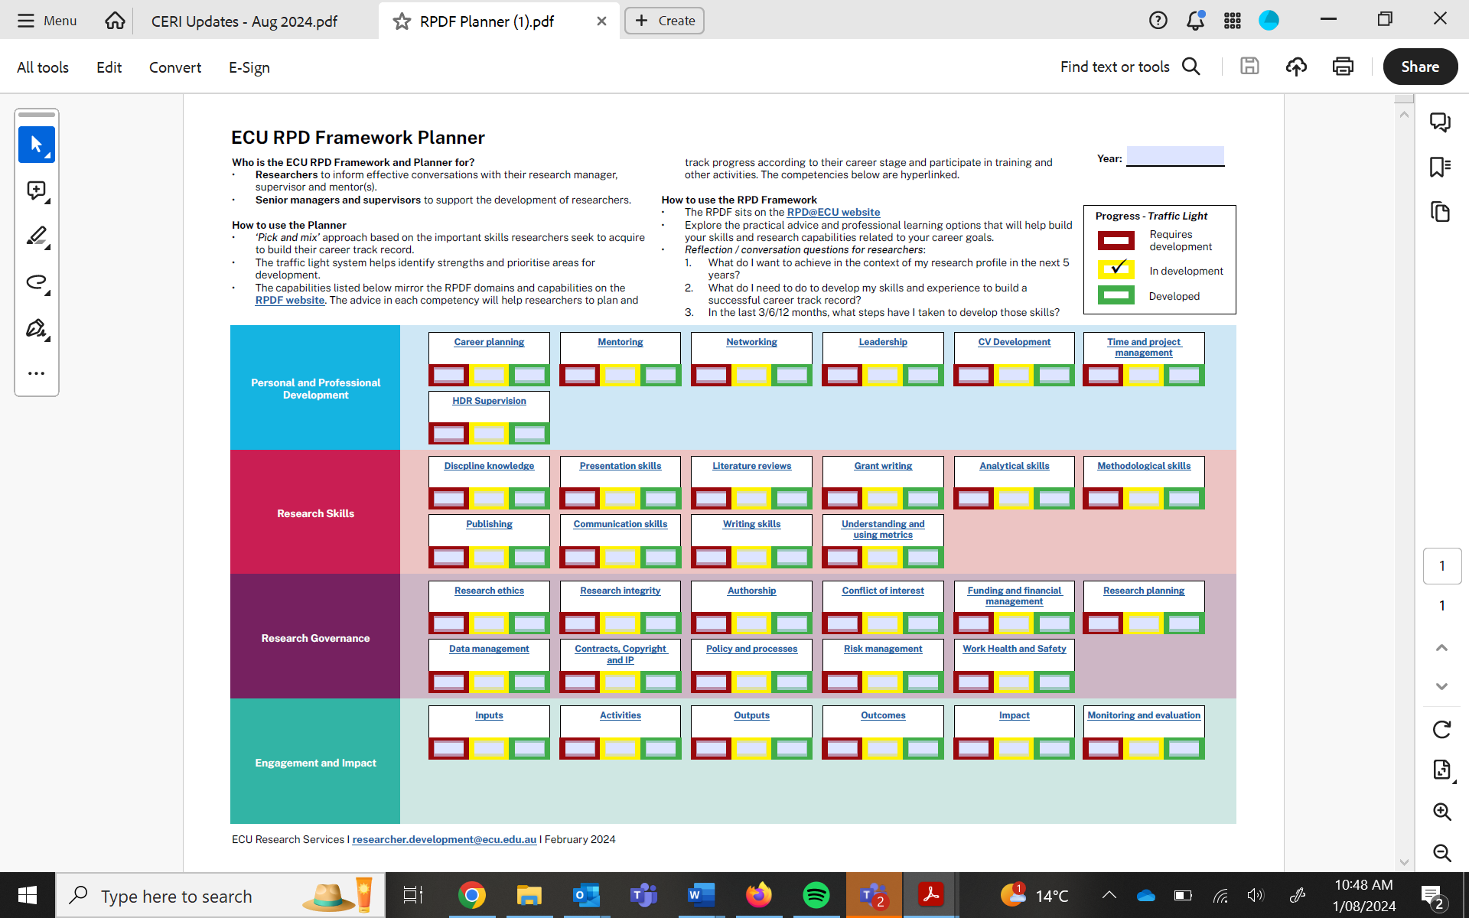

Provide comment on your above self-assessment/audit within this text box.

**Write your text here**

In completion of this section, you may wish to consider your strengths, areas for development, opportunities and other considerations. Some questions to prompt this reflection are provided below:

Strengths

What are your qualifications, accreditation and technical skills? What are your specific transferable skills? What do you enjoy? What do you do well? What experience do you have? What do you feel confident doing? Do you have specialist skills and knowledge? What are your key personality traits? What reputation do you have?

Areas for development

What are your weaknesses? Do you have gaps in your skills, knowledge, abilities and experiences? What do you not do well? Are you motivated? What do you or should you avoid? Do you have personality traits that may hinder your progress? What relevant work experience do need to develop?

Opportunities

What are your objectives in completing this award? What goals do you have? How can you improve your qualifications, skills and experience? What are the trends in your discipline? What are your career plans and objectives?

Considerations

Do you have obstacles that may influence your progression? What potential changes may you need to plan for? Do you have family or other commitments that should be considered within your Learning Plan. Do you have any health or other considerations that should be considered within your Learning Plan.

1. **Consult** **and confirm** with supervisors, advisors, mentors and others
   1. Candidates are encouraged to discuss and seek advice on their professional development requirements relevant to their research and future career planning.
   2. Supervisors are important advisors regarding such professional development. However, others such as peers, mentors and learning support officers can assist with advice and raise awareness of professional development opportunities.
   3. When consulting with others candidates should consider future activities required within research and future career ambitions.
   4. Details are provided below.

Supervisor comment and recommendations:

1. **Plan/Record** activities to further improve and enhance learning
   1. In consultation with supervisors, candidates should identify appropriate professional development opportunities.
   2. Planning should consider professional development needs of the candidate important to their research and future career objectives.
   3. Candidates should consider both their professional development needs and timing of such activities.
   4. When planning activities candidates are encouraged to review the relevant requirements of the course (i.e. milestone requirements) particularly relevant to your stage of candidature. Candidates are also encouraged to review professional development opportunities advertised by their School or Discipline, Research Services, Centre for Learning and Teaching, Library Services, SOAR peer advisors, relevant external networks, industry etc.
   5. Candidates should record the planning and completion of activities and, where applicable, evidence of achievement (i.e. certificate of completion).

Outline details of your current research and career aspirations.

Complete the Professional Development Plan below. Examples of how to complete the table is provided in grey. Delete text and provide your own list of activities to achieve/complete.

|  |  |  |  |
| --- | --- | --- | --- |
| **Domain** | **Area/Skill** | **Activity or achievement** | **Time Frame** |
| Professional and Personal Development | Improve understanding of Graduate Research at ECU | Complete Graduate Research Induction Program (GRIP) | dd/mm/yy |
| Professional and Personal Development | Industry engagement | Identify HDR Internship opportunity with Supervisors | dd/mm/yy |
| Professional and Personal Development | Academic experience | Seek opportunities for tutoring within discipline/School | dd/mm/yy |
| Research Governance | Improve understanding of Research Ethics and Integrity | Complete ECU Research Integrity (RIPL) Training Modules | dd/mm/yy |
| Research Governance | Work health Safety Induction | Complete Work Health Safety Modules | dd/mm/yy |
| Research Governance | Authorship | Complete publication plan with supervisors | dd/mm/yy |
| Research Skills | Creative and Critical thinking; Methodological skills | Attend developing and Refining Research Questions Workshop | dd/mm/yy |
| Research Skills | Discipline knowledge | Extensively review current literature and develop draft of literature review | dd/mm/yy |
| Engagement and Impact | Understanding and using metrics | Establish ORCID ID and appropriate web-profiles | dd/mm/yy |
| Engagement and Impact | Collaboration and translation | Identify and engage with appropriate professional associations in discussion with supervisors | dd/mm/yy |
| Engagement and Impact | Industry collaboration | Identify potential industry mentor | dd/mm/yy |

1. **Revisit** the Learning Plan throughout your candidature
   1. Candidates are required to complete an initial Learning Plan in requirements for completion of Milestone 1. However, the Learning Plan is an active document and should be regularly revisited.
   2. The HDR research progress reports (completed at the end of each enrolment period) provide an opportune time to revisit your HDR Learning Plan with your Supervisors.

We plan to revisit this Learning Plan on dd/mm/yy

**Candidate Signature:** ________________________________

Date: __________________________

**Principal Supervisor Signature:** ________________________________

Date: __________________________

**Appendix 1:**

Below provides examples of professional development opportunities candidates may wish to consider when developing their learning plan.

|  |  |  |  |
| --- | --- | --- | --- |
| **Domain** | **Skill** | **Explanation/requirement** | **Examples of evidence** |
| Personal and Professional Development | Time and Project Management | Apply knowledge, skills and techniques to coordinate activities and meet demands of complex and multi-dimensional projects. Develop an appropriate project plan and work both individually and within a team to meet criteria within the required time frame. Ability to develop, coordinate and report on a research budget. | Development of a project plan with clear budget and timeline; Management plan considering work/life balance. |
| Personal and Professional Development | Leadership, Teaching and Mentorship | Ability and experience in leading research projects and teams. Educating, teaching or guiding individuals through ideas, principles or methodologies. Provide mentoring to junior researchers. | SOAR Peer Advisers; tutoring or lecturing experience; supporting peers |
| Personal and Professional Development | Teamwork and Collaboration | Ability to work well within in a group and to collaborate effectively to complete required tasks. Respect and embrace diversity by encouraging input from others with different beliefs, experiences and qualities to our own. |  |
| Personal and Professional Development | Career Planning | To consider and plan work, study and learning opportunities to ensure that your development aligns with career aspirations. | Internship or experience with relevant industry partner; Developed CV. |
| Research Skills | Creative and Critical thinking | Ability to critically review the literature, or current body of knowledge in order to develop research hypotheses, ideas and questions. Provide a clear, concise and logical arguments. High level critical thinking and problem solving to identify research problems and conceptualise research. Identify and evaluate key theories and methodologies in the discipline. | Research proposal with clearly stated research problem, research question(s)s or hypotheses; Clearly justified research methodology and methods included in research proposal; Research proposal includes a critical assessment of the relevant literature to justify the research approach. |
| Research Skills | Methodological Skills | Sound understanding of quantitative and qualitative research methods, with sufficient knowledge and understanding to evaluate appropriate methodology relevant to your research area. Appropriate knowledge, skills, practical experience and level of qualification required to undertake research methodologies appropriate to your research. | Detailed proposed research methodology; Experience in data collection, analysis and interpretation techniques relevant to discipline. |
| Research Skills | Written Communication | Communicate research and express ideas using written English and appropriate language for the relevant discipline. To be able to convey information effectively and accurately both within scholarly research outputs and to a lay audience. | Peer reviewed publication; Research proposal; grant application; written report; research proposal. |
| Research Skills | Oral Communication | Communicate, summarise and discuss research through to an individual or group setting in a clear and engaging manner. Appropriately adapt communication style and presentation format to suit the audience. | Oral research proposal; Oral presentation at Conference or Symposia; Tutoring or lecturing; Proposal Seminar; Oral Defence; Consultation and communication with community; Engagement with potential participants. |
| Research Governance | Academic Integrity | Adhering to the highest standard of academic integrity. Awareness of responsibilities, acting with academic integrity, and understanding and avoiding academic misconduct. | Knowledge of ECU Academic and Research Integrity Policy and guidelines; completion of [Academic Integrity Training Modules](https://intranet.ecu.edu.au/student/my-studies/academic-integrity);  Ability to reference according to relevant discipline; Knowledge and experience in the use of referencing software. |
| Research Governance | Research Integrity, Governance, Ethics and Data Management | Apply the Australian Code for Responsible Conduct of Research and other appropriate legislative requirements or guidelines to ensure research is conducted with integrity and in an ethical, responsible and professional manner. Detailed understanding of individual and organisational responsibilities in the conduct of ethical and responsible research, particularly with regards to your relevant research area. | Knowledge and understanding of appropriate legislation, policies or guidelines; Completion of Research Professional Development (RIPL) modules; Complete ethics application and obtain ethics approval; Completion of Risk Assessment. |
| Engagement and Impact |  |  | Co-supervision or internship with Industry; Research publication plan. |

More information is available at the following:

* [ECU Learning Support](https://edithcowanuni-my.sharepoint.com/personal/s_smart_ecu_edu_au/Documents/Desktop/DESKTOP/•%09https:/www.ecu.edu.au/centres/centre-for-learning-and-teaching/learning-support)
* [Career and Skills development](https://www.ecu.edu.au/careers-and-employability-services/overview)