Internal Signage Request

Name:
Email:
Extension:
Faculty/School/Centre:
Campus:
Charge Account (if applicable):
Subject:
Have you referred to ECUSIS for specific locations and room numbers?

ITEM | PRIORITY  1-5 | BUILDING AND LOCATION | PHOTO | DESCRIPTION AND AMMENDED TEXT | NOTES | PREFFERRED DUE DATE
1 eg. | 1 | JO8A - Corridor 215 | 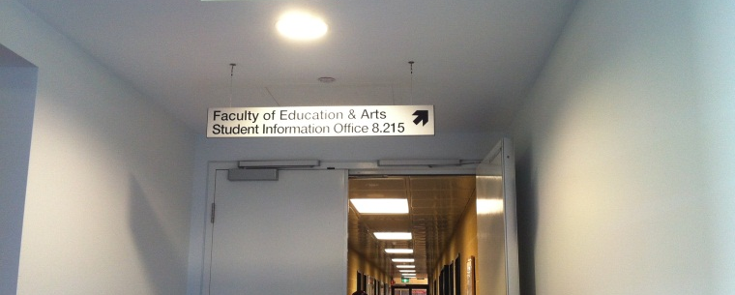 | Remove sign. |  | 15.03.2014
2 eg. | 2 | JO19.183 – external entrance, on glass beside door | 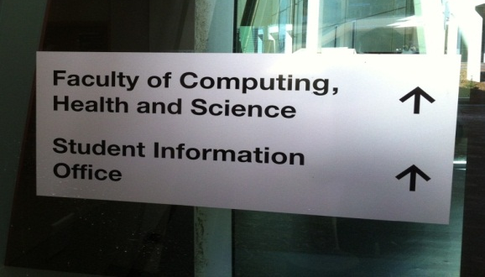 | Remove second line arrow. Update faculty name.  Sign to read:  Faculty of Health Engineering and Science ↑  Student Information Office | Vinyl on glass | 15.03.2014
1
2
3
4
5
6
7
8
9
10
Notes:
Please insert priority (if applicable) 1 = High, 5 = Low

Internal Signage Request March 2014
All printed copies are uncontrolled Issue 1

