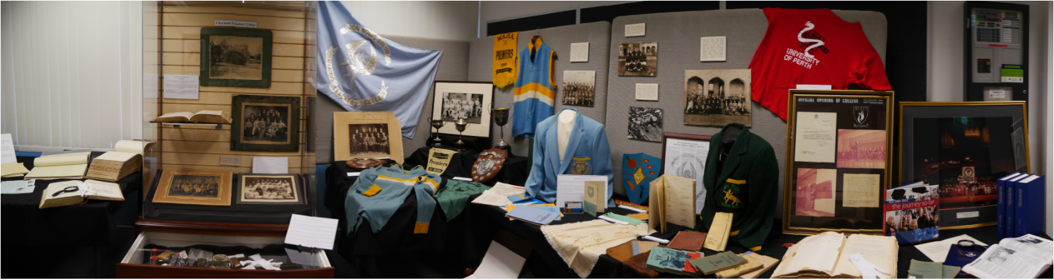

Archive Access – Request Form
Please return to records@ecu.edu.au
To be completed by the requestor

Name:
Contact Telephone |  | Date Request Made:
Contact Email Address:
Relationship to ECU ☐ Ex Staff Member ☐ Ex Student ☐ Current Staff Member

☐ Family Member of Ex ☐ Researcher / Historian
Student / Staff Member

☐ Other

Scope of Request: The more detail you can provide about what you are looking for, the easier a search will be. Try and be as specific as possible and include names (married and maiden) dates, campus information, courses studied etc.

What information are you looking for?
Details of individuals (include maiden & married names)
Date Range of Search?

Relevant Campus ☐ Claremont ☐ Nedlands ☐ Graylands
☐ Churchlands ☐ Mount Lawley ☐ Bunbury
☐ Joondalup

☐ Teachers College ☐ WACAE ☐ ECU

Completed by RAMS

Actioning Officer

What further information is needed?
Contact Requester

Information found

Requester contacted & date of access set

